

**HOME WORK**

**8.1,8.2,8.3,8.4**



**November 20, 2020**

**RAIHAN MD RAKIBUL ISLAM**

**2020380029**

**8.1**

**2. a)** Find a recurrence relation for the number of permutations of a set with n elements.

**Sol:**

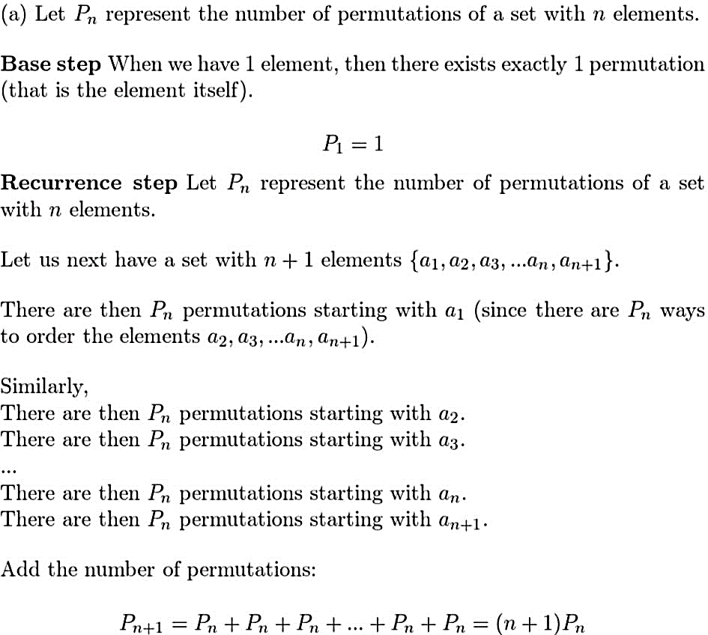

**b)** Use this recurrence relation to find the number of permutations of a set with n elements using iteration.

**Sol:**

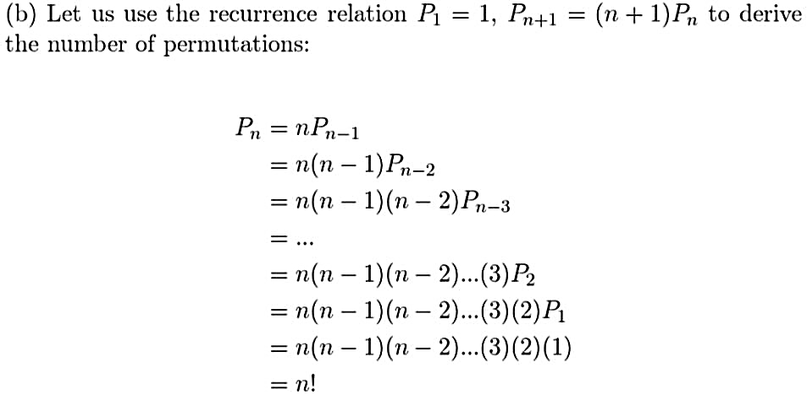

**6. a)** Find a recurrence relation for the number of strictly increasing sequences of positive integers that have 1 as their first term and n as their last term, where n is a positive integer. That is, sequences a1, a2, . . . , ak, where a1 = 1, ak = n, and aj < aj+1 for j = 1, 2, . . . , k − 1.

**Sol:**

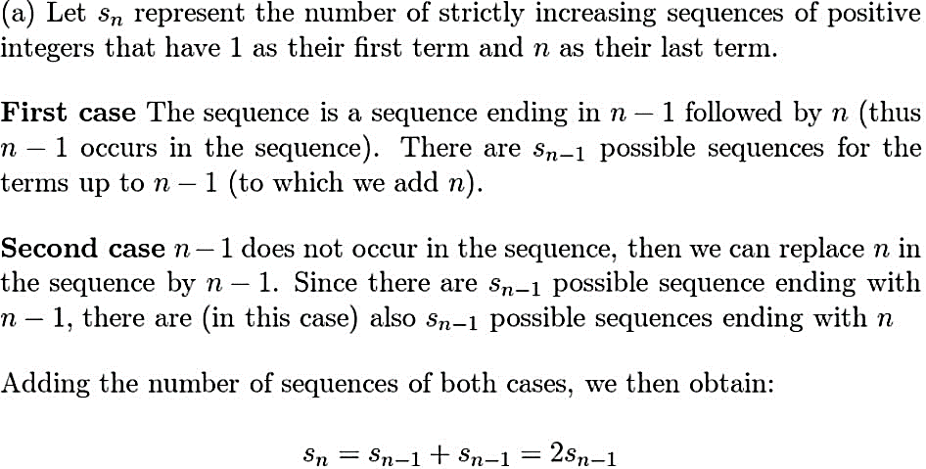

**b)** What are the initial conditions?

**Sol:**

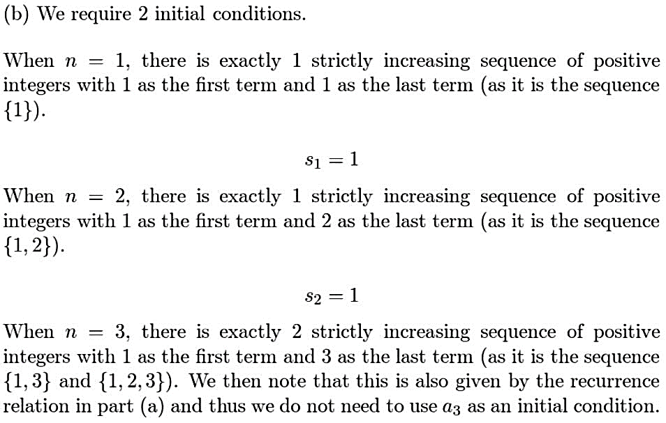

**c)** How many sequences of the type described in (a) are there when n is an integer with n ≥ 2?

**Sol:**

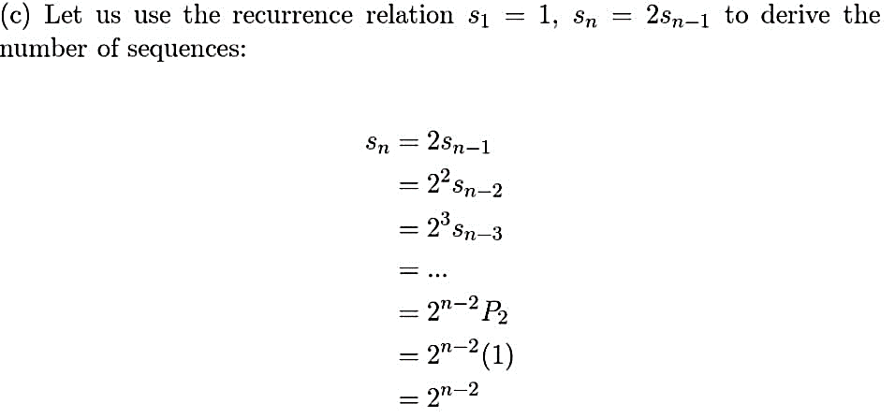

**24.** Find a recurrence relation for the number of bit sequences of length n with an even number of 0s.

**Sol:**

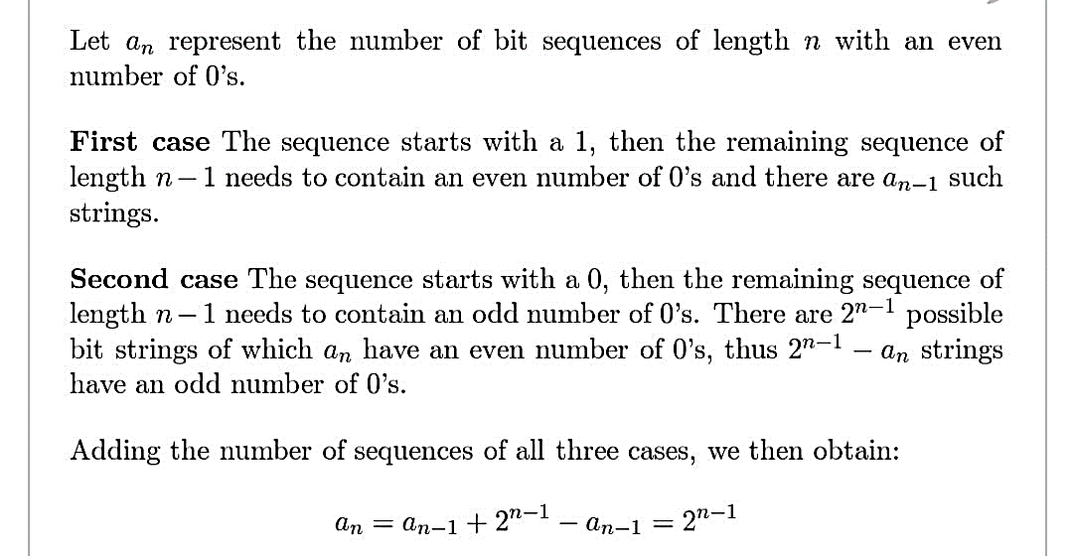

**8.2**

4. Solve these recurrence relations together with the initial conditions given.

a) $a_{n}$ = $a_{n-1 }$ + 6 ${a }_{n-2}$ for n ≥ 2, $a_{0}$ = 3, $a_{1}$ = 6

**Sol:**

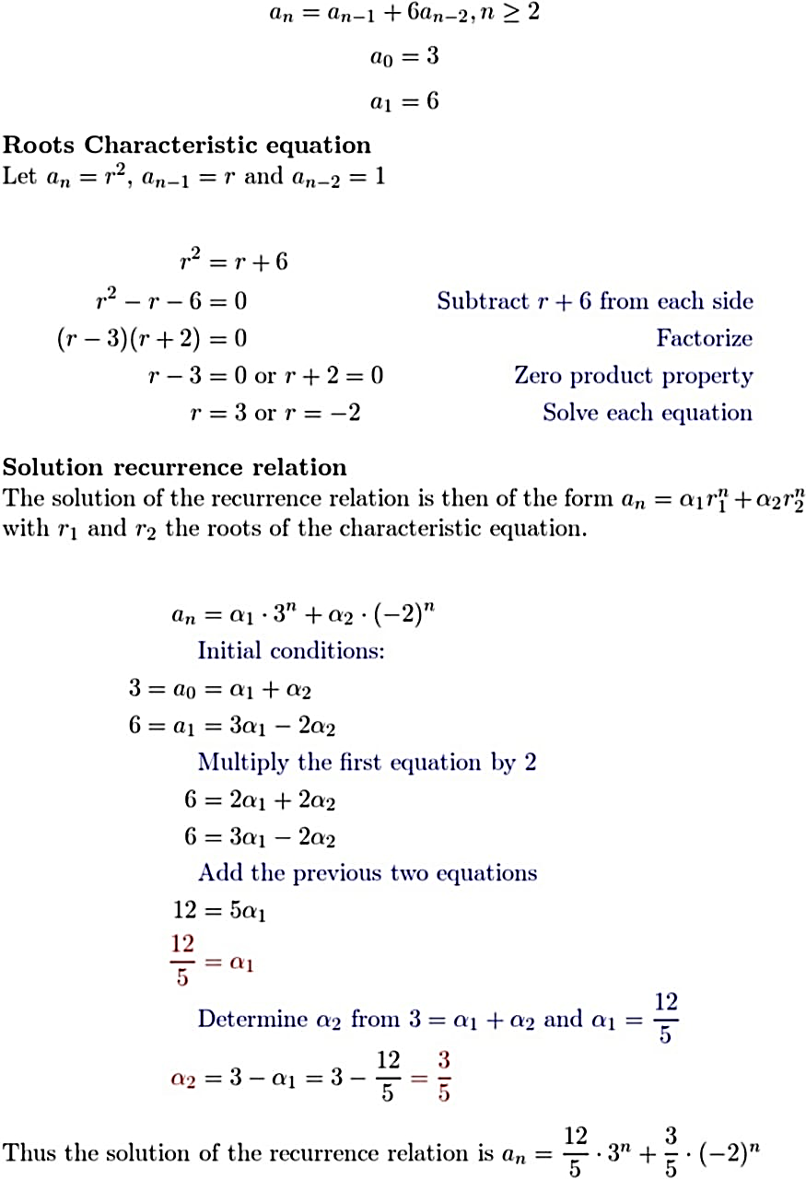

c) $a_{n}$ = 6 $a_{n-1 }$ − 8 ${a }_{n-2}$ for n ≥ 2, $a_{0}$ = 4, $a_{1}$ = 10

**Sol:**

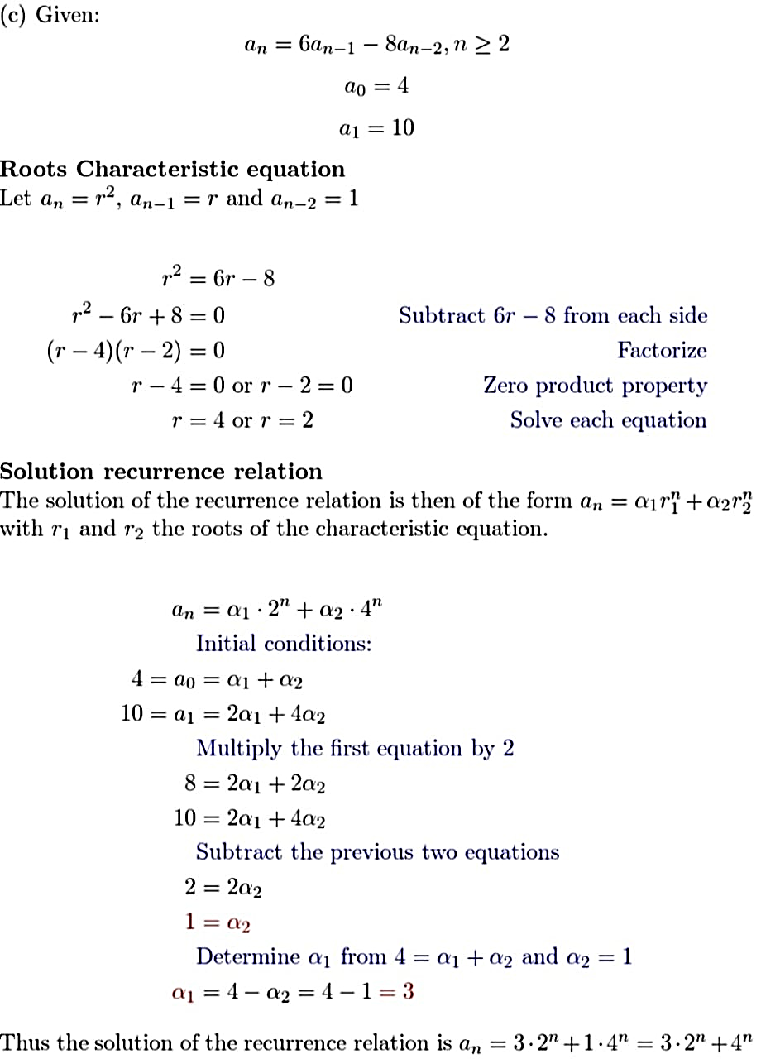

e) $a_{n}$ = ${a }_{n-2}$ for n ≥ 2, $a_{0}$ = 5, $a_{1}$ = −1

**Sol:**

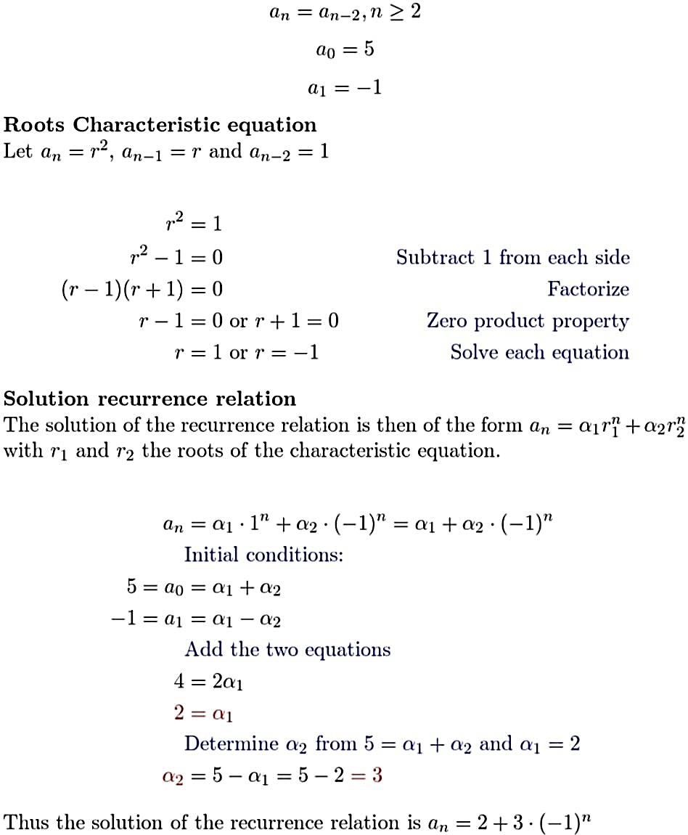

g) ${a }_{n+2}$ = −4 $a_{n+1 }$ + 5 $a_{n}$ for n ≥ 0, = 2, = 8

**Sol:**

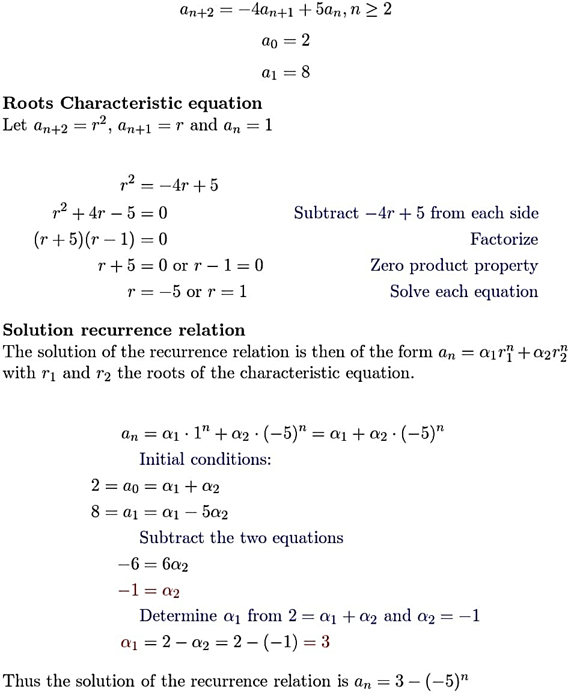

11. The Lucas numbers satisfy the recurrence relation $L_{n}$ = $L_{n-1 }$ + $L_{n-2}$, and the initial conditions $L_{0}$ = 2 and $L_{1}$ = 1.

a) Show that $L_{n}$ = fn−1 + fn+1 for n = 2, 3, . . . , where $f_{n}$ is the nth Fibonacci number.

**Sol:**

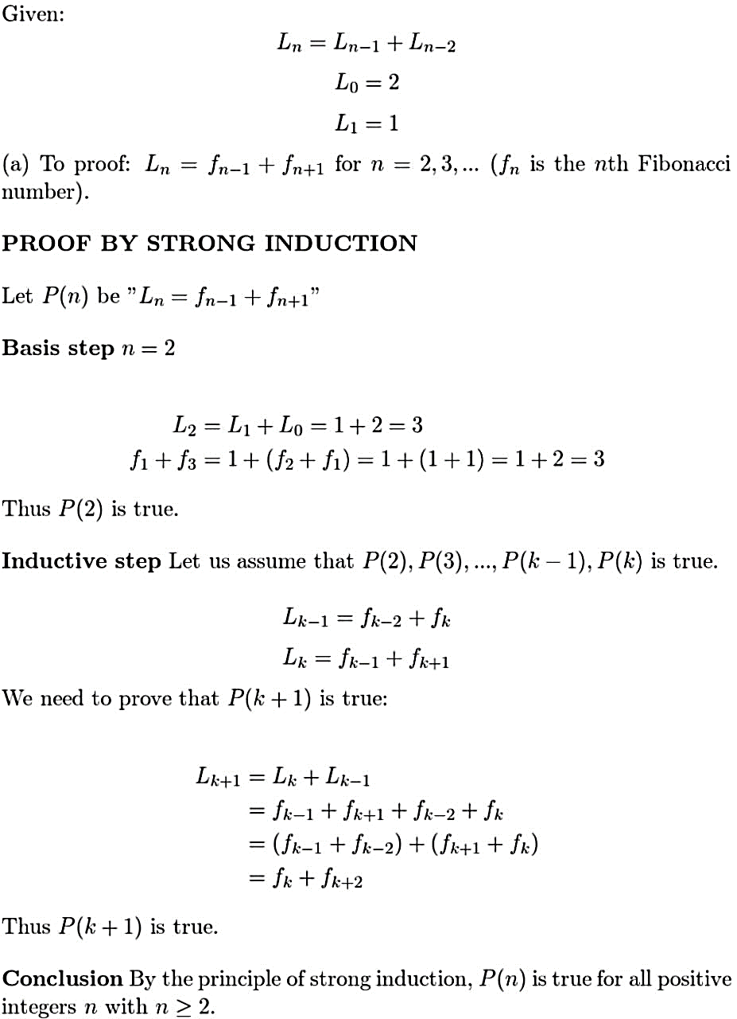

b) Find an explicit formula for the Lucas numbers.

**Sol:**

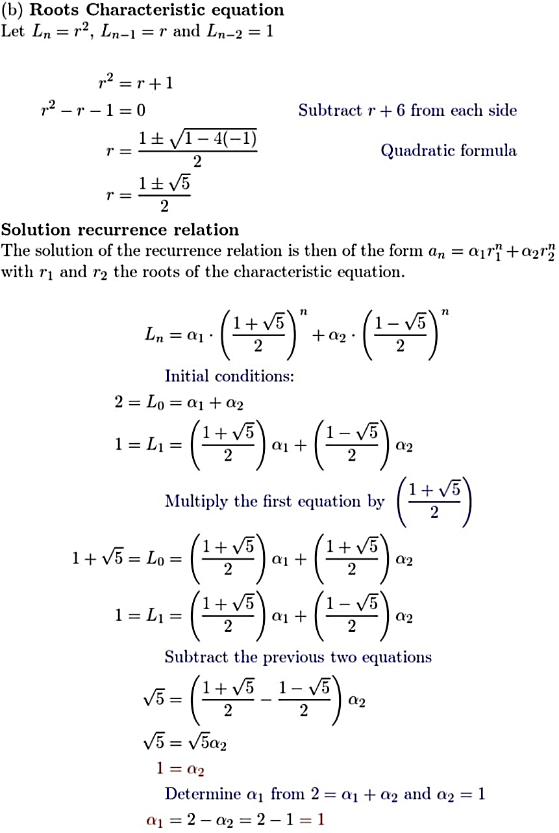

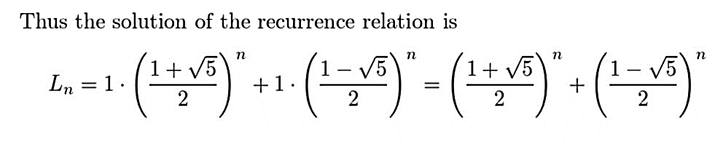

24. Consider the nonhomogeneous linear recurrence relation $a_{n}$ = 2 $a_{n-1 }$ + $2_{n}$.

a) Show that $a_{n}$ = ${n2}^{n}$ is a solution of this recurrence relation.

**Sol:**

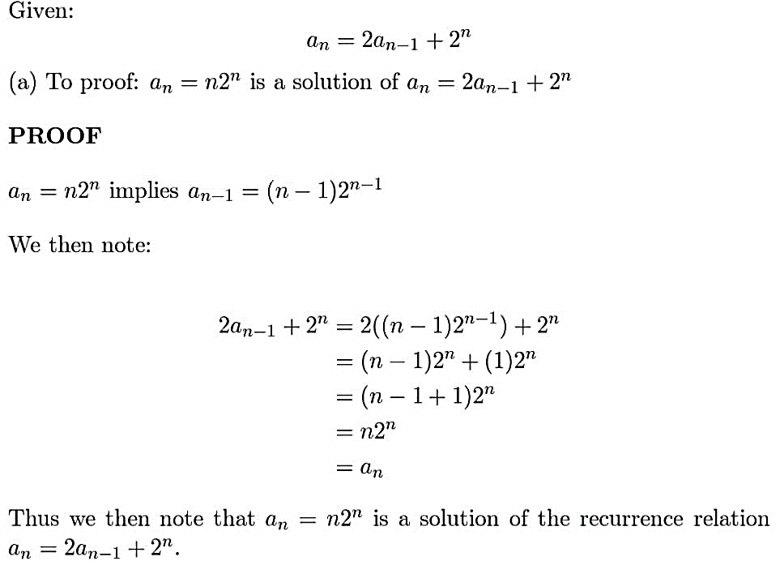

b) Use Theorem 5 to find all solutions of this recurrence relation.

**Sol:**

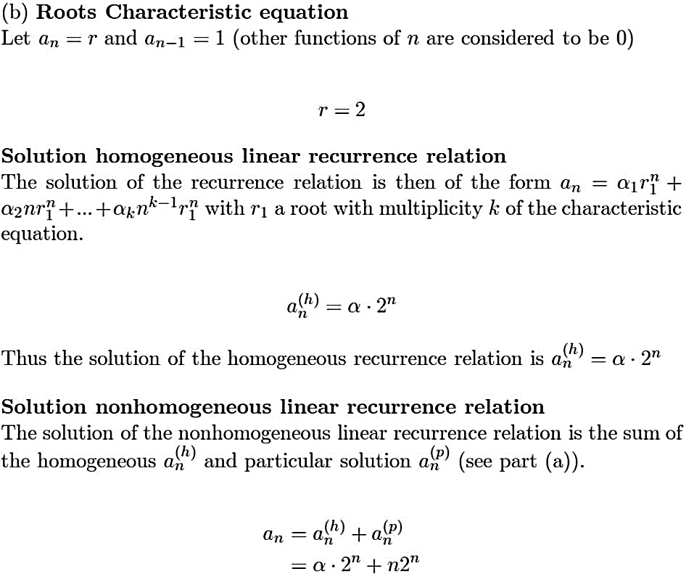

c) Find the solution with $a_{0}$ = 2.

**Sol:**

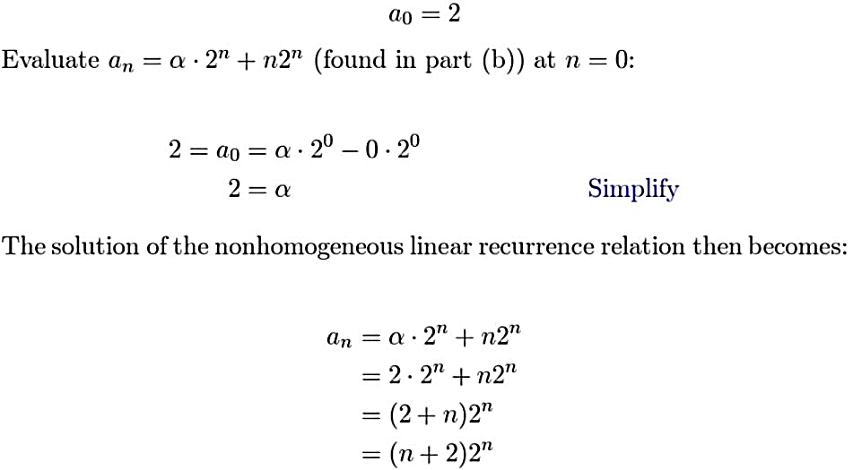

**8.3**

6. How many operations are needed to multiply two 32 × 32 matrices using the algorithm referred to in Example 5?

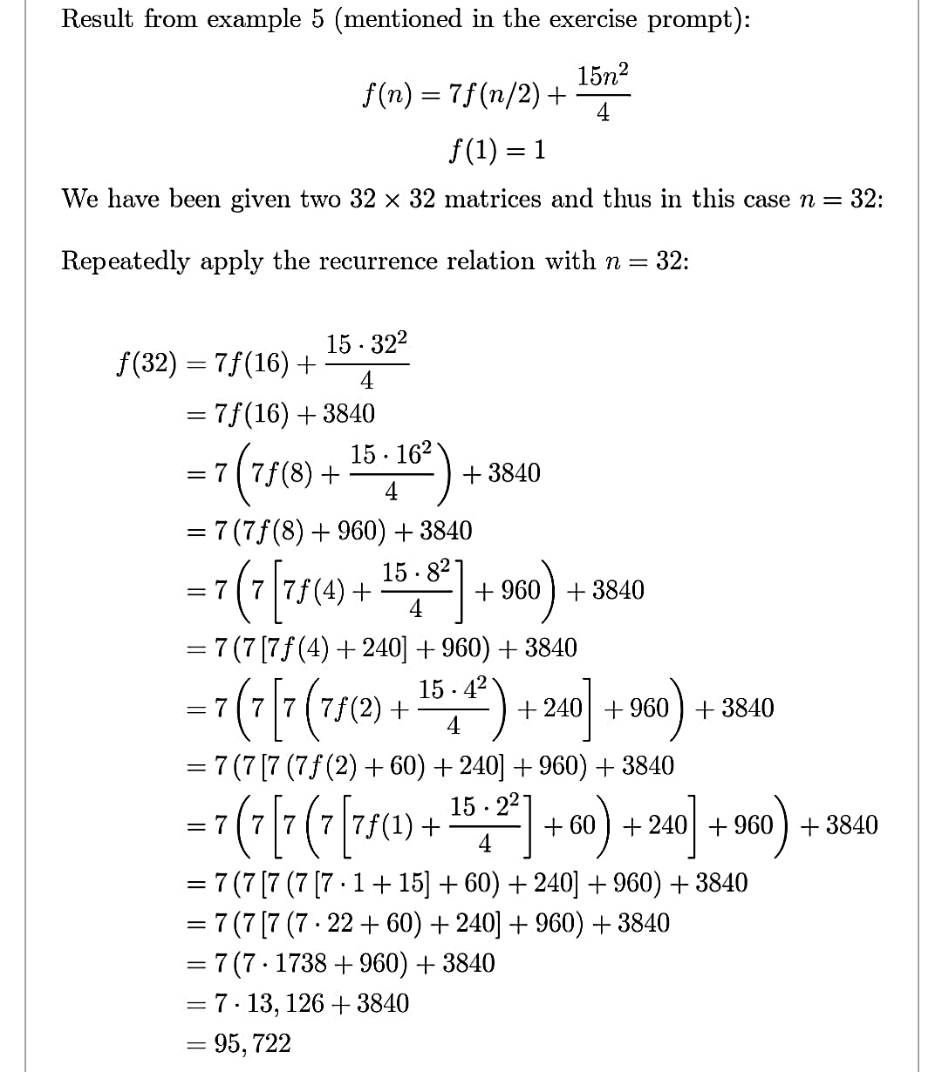**Sol:**

10. Find f (n) when n = $2^{k}$, where f satisfies the recurrence relation f (n) = f (n/2) + 1 with f (1) =1.

**Sol:**

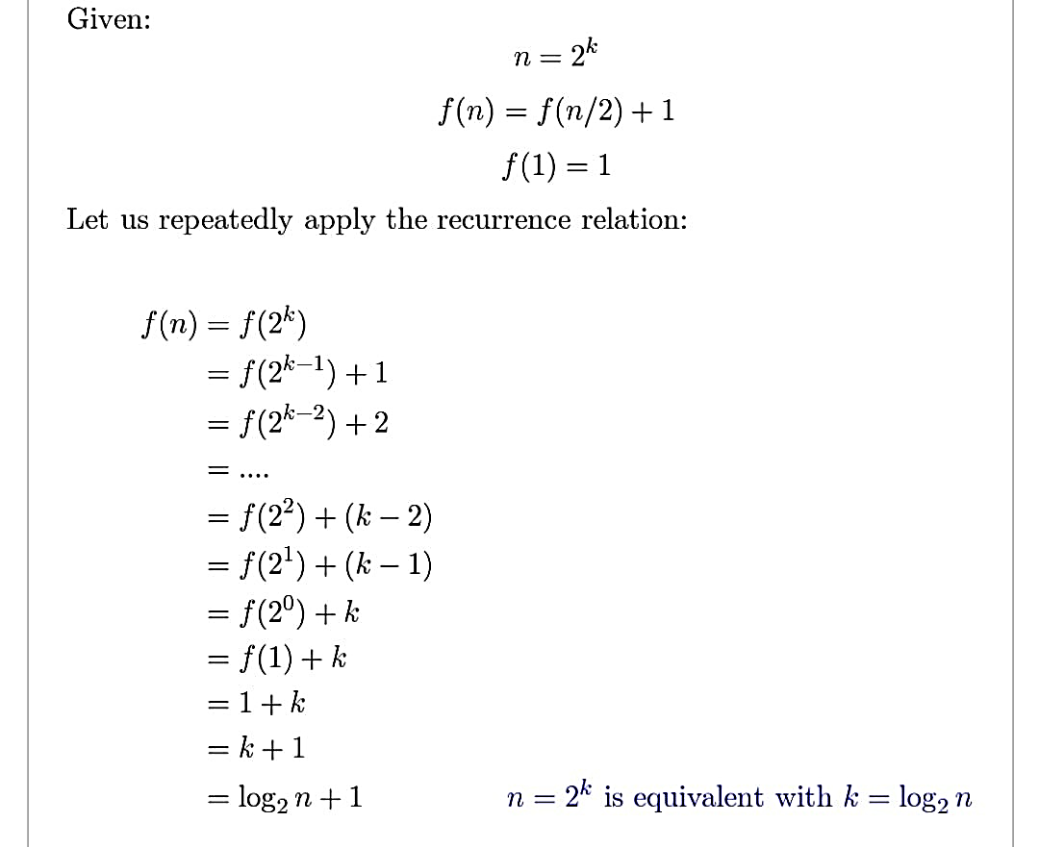

20. a) Set up a divide-and-conquer recurrence relation for the number of modular multiplications required to compute $a^{n}$ mod m, where a, m, and n are positive integers, using the recursive algorithms from Example 4 in Section 5.4.

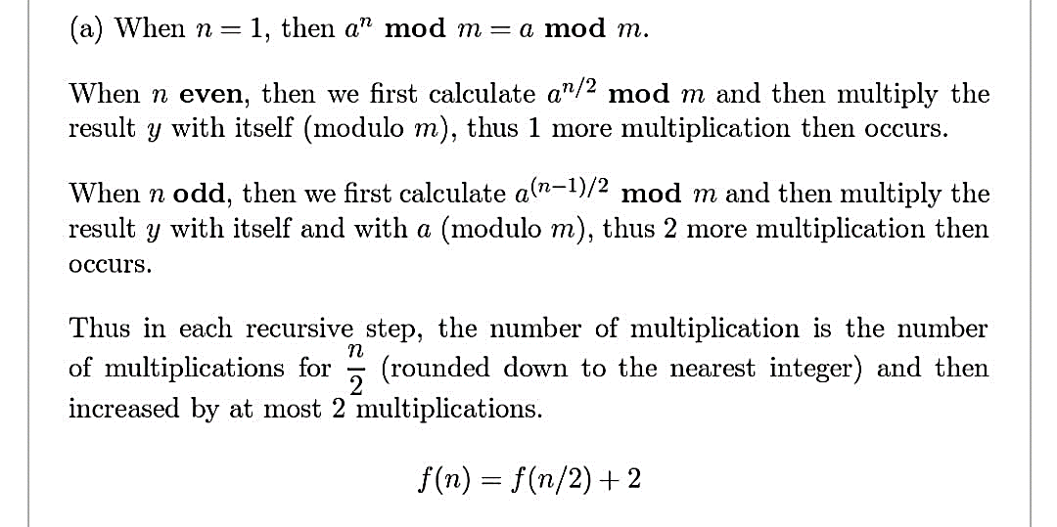**Sol:**

**b)** Use the recurrence relation you found in part (a) to construct a big-*O* estimate for the number of modular multiplications used to compute $a_{n}$**mod** *m* using the recursive algorithm.

**Sol:**

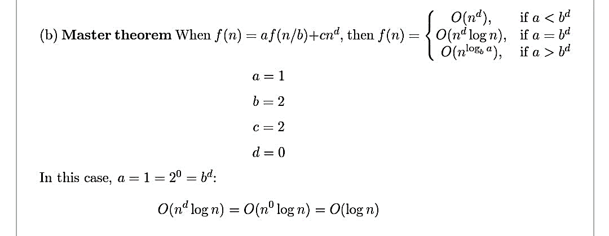

**8.4**

8. For each of these generating functions, provide a closed formula for the sequence it determines.

a) ${(x^{2} + 1)}^{3}$

**Sol:**

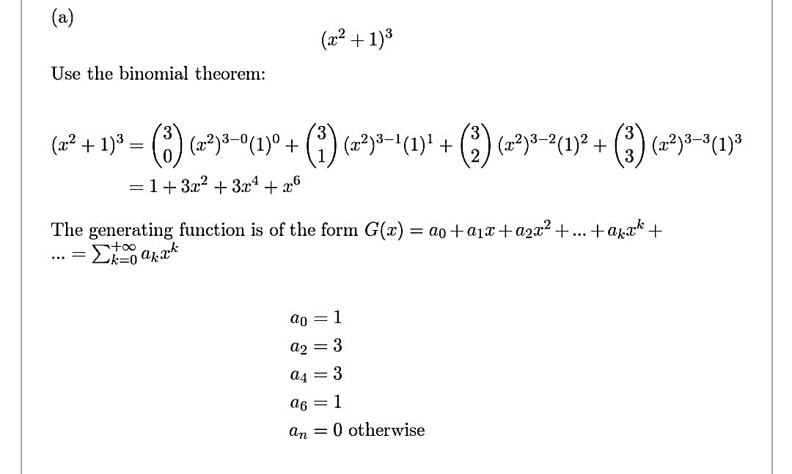

c) 1/(1 − 2 $x^{2}$)

**Sol:**

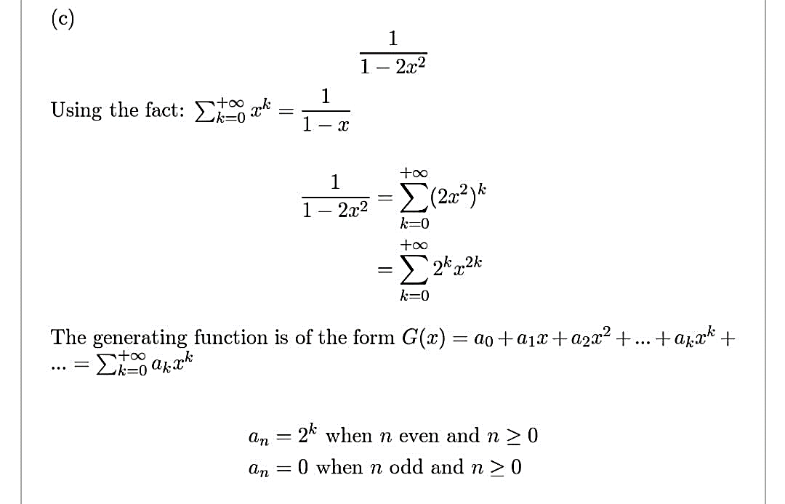

e) x − 1 + (1/(1 − 3x))

**Sol:**

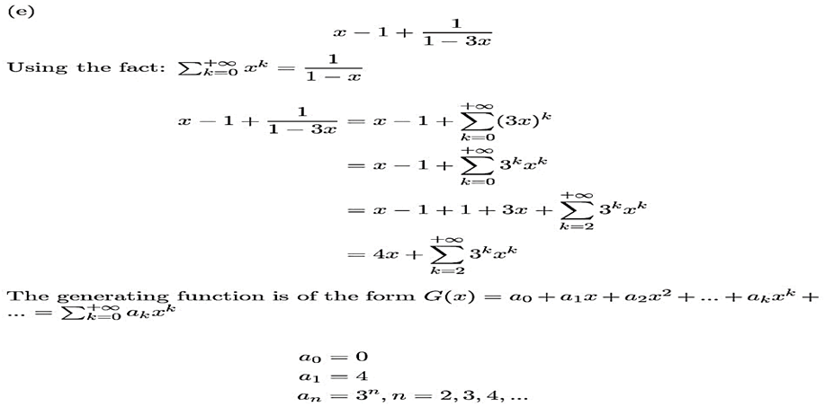

12.Find the coefficient of x12 in the power series of each of these functions.

a) 1/(1 + 3x)

**Sol:**

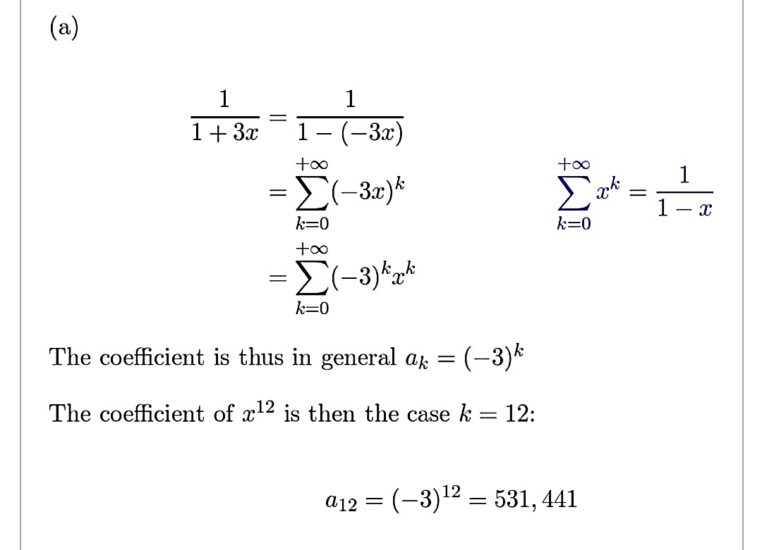

c) 1/ ${(1 + x) }^{8}$

**Sol:**

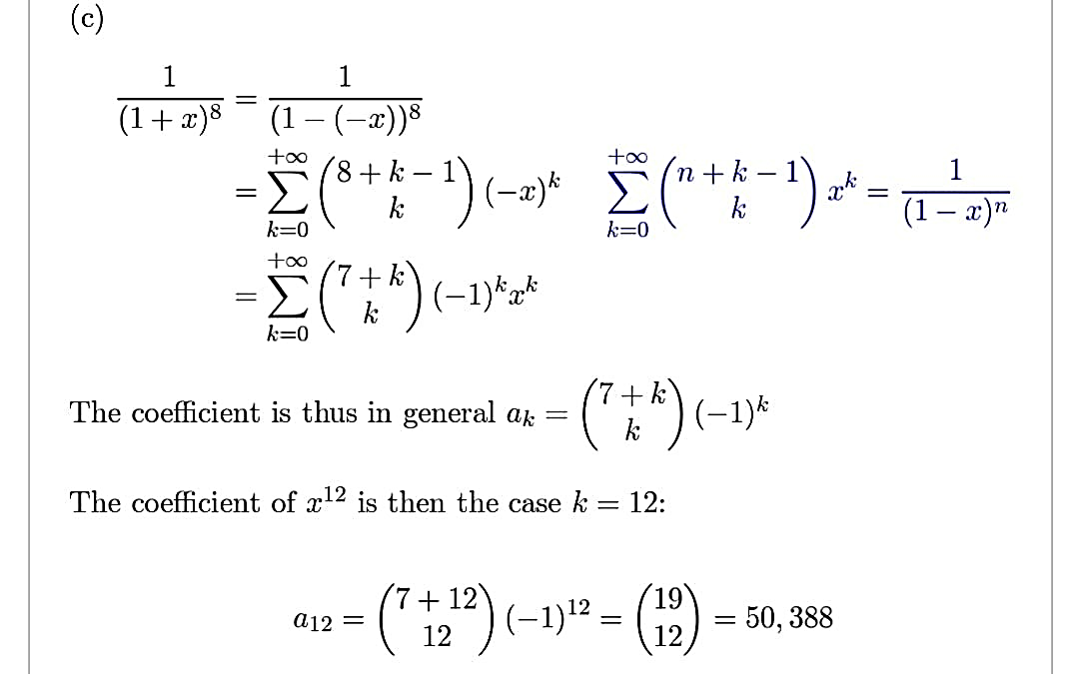

e) $x^{3}{/(1 + 4x)}^{2}$

**Sol:**

